AI-BASED BANKING TRANSACTION FRAUD DETECTION SYSTEM
Submitted in partial fulfillment ofthe requirement for the award ofthe degree

Bachelorof Science
In the faculty of Computer Science with Data Analytics of Bharathiar University, Coimbatore Submitted by

S VIKASHINI
(Register No: 2328B0140)

Under the Guidance of

Mrs. R. RINIPRIYA MCA.,

Assistant Professor, Department ofComputer Science with Data Analytics

Department of Computer Science with Data Analytics

ST. JOSEPH’S COLLEGE FOR WOMEN
Affiliated to Bharathiar University Accredited byNAAC with Grade ‘A’ (Cycle II)
(Recognized under section 2(f) and 12(B) ofthe UGC Act, 1956) Certified by ISO 9001:2015

Tirupur– 641 604
March - 2026



Department of Computer Science with Data Analytics St. Joseph’s College for Women, Tirupur – 4 Affiliated to Bharathiar University
Accredited by NAAC with ‘A’ Grade (Cycle II) (Recognized under section 2(f) and 12(B) ofthe UGC Act, 1956)
Certified by ISO 9001:2015

CERTIFICATE
This is to certify that the project work entitled “AI-BASED BANKING TRANSACTION FRAUD DETECTION SYSTEM” is submitted to Bharathiar University, Coimbatore in partial fulfillment of requirement for the award of the Degree of Bachelor of Science is a record of the original work done by VIKASHINI S (2328B0140) under my Supervision and guidance and that project work has not formed the basis for the award of any Degree/Diploma or similar title to any candidate of any University.

Internal Guide Head of the Department

Viva-voce Examination was conducted on , in St. Joseph’s College for Women, Tirupur – 641604.

Internal Examiner External Examiner
Date : Date :

I, hereby declare that the project work entitled “AI-BASED BANKING TRANSECTION FRAUD DETECTION SYSTEM” is submitted to the Department of Computer Science with Data Analytics, St. Joseph’s College for Women, Tirupur affiliated to Bharathiar University, Coimbatore in the partial fulfillment of the requirement for the award of Bachelor of Science is an original work done by me during the sixth semester.

Place: Signature of the Candidate
Date: VIKASHINI S

At first and foremost I would like to thank God Almighty for blessing me with good health and strength throughout this project work.

My profound gratitude to Rev. Sr. Dr. A. Arulseeli.,M.A., M.Phil., Ph.D., Secretary, St. Joseph’s College for Women for the encouragement rendered to me during this project.

My profound gratitude to Dr. S. Sahaya Tamil Selvi M.Sc., M.Phil., MBA, SET., Ph.D., Principal, St. Joseph’s College for Women for the encouragement rendered to me during this project.

It’s my privilege to thank Mrs. C. Kavitha M.Sc., M.Phil., SET., Assistant Professor & Head, Department of Computer Science with Data Analytics for her valuable guidance and support throughout the project development work.

I express my deep sense of gratitude and sincere thanks to my guide
Mrs. R. Rinipriya MCA., Assistant Professor, Department of Computer Science for providing all sorts of guidance to complete my project successfully.

I also extend my sincere thanks to all faculty members of the department and technical assistants for their co-operation and valuable guidance.

I thank our college library for providing me with many informative books that helped me to enrich my knowledge to bring out the project successfully.

I amgrateful to myparents for their continued encouragement that theyhad given me.

The AI-Based Banking Transaction Fraud Detection System is designed to identify fraudulent transactions using a combination of rule-based analysis and machine learning techniques. The system analyzes transaction details such as amount, time, location, device, and transaction type to determine whether a transaction is normal or fraudulent. The project also provides visual analysis using charts and stores transaction data for future reference.
The AI-Based Banking Transaction Fraud Detection System is designed to detect and prevent fraudulent banking transactions by using a combination of rule-based analysis and machine learning techniques. The system examines important transaction details such as transaction amount, transaction time, location, device type, transaction type, and previous fraud history to identify suspicious behavior. Based on this analysis, the system classifies each transaction as either normal or fraudulent.

To improve accuracy, the system applies predefined rules for obvious fraud cases and uses a machine learning algorithm to detect complex fraud patterns. The project also provides visual analysis through charts, helping users and administrators easily understand transaction trends. All transaction details and results are stored securely for future reference and analysis. This system helps enhance banking security, reduce fraud risks, and support faster decision- making.

INTRODUCTION
In recent years, digital banking and online transactions have grown rapidly due to technological advancements. While this growth has made banking services faster and more convenient, it has also increased the risk of financial fraud. Fraudulent transactions can cause financial loss, reduce customer trust, and affect the reputation of banks.Traditional fraud detection methods mainly rely on manual verification and simple rules, which are inefficient and time-consuming. These methods are unable to adapt to new fraud patterns. Therefore, there is a strong need for an intelligent fraud detection system that can automatically analyze transactions and detect fraud accurately.This project focuses on developing an AI-based system that helps banks identify suspicious transactions using machine learning and predefined rules.

Needfor Fraud Detection System:

With the increasing number of online transactions, manual monitoring of each transaction is not practical. Traditional systems that rely only on fixed rules are often unable to detect complex and new fraud patterns. Fraudsters continuously change their techniques, making it difficult for static systems to identify suspicious activities. Therefore, there is a strong need for an intelligent fraud detection system that can automatically analyze transaction data, learn from historical records, and accurately identify fraudulent transactions. Such a system can help banks reduce financial losses and improve customer trust.

Role of Artificial Intelligence inFraud Detection:

Artificial Intelligence (AI) plays a crucial role in modern fraud detection systems. AI-based systems can analyze large volumes of data, identify hidden patterns, and make accurate predictions. Machine learning algorithms learn from past transaction data and improve their performance over time. By using AI techniques, fraud detection systems can detect unusual transaction behavior such as abnormal transaction amount, unusual transaction time, unknown device usage, and unexpected location changes. This makes AI-based fraud detection systems more effective than traditional methods.

ORGANIZATION PROFILE
KICE INFO SYSTEMS is a professional website designing, Customized Software development, Business process Outsourcing – IT/ITES & Internet marketing Company providing full featured web services including B2B Acquisition & B2C Ecommerce solutions and acting as an offshore development center for overseas Development firms. KICE Info systems is an innovative company, based in India that Provides a series of Web-based and software applications that have helped their Customer to create successful business ventures through online initiatives. KICE Info Systems provide all the services that a company needs to get online from web designing To web hosting and manage leading-edge Web sites and e-business applications. Quality and Client Satisfaction are primarily the telling factors of KICE Info systems Success in the domestic market. Ever since its inception, KICE Info systems has Accrued continuous growth in all its business functions and this has been possible only Due to its commitment, quality training methodologies, the services it offers, knowledge Sharing with industry leaders and professional approach .

Services
- Professional WebDesign
- SEO concerts, Internet Marketing

- Payper Click Campaign

- Link Building, Ecommerce Solution

- Web Application Development

- Multimedia Presentations

- Customized Software development

- Business Process Outsourcing- IT/IT.

  - System Specification

Hardware Configuration
Processor: IntelCore i3
RAM: Minimum4 GB (Recommended 8 GB)

Hard Disk: 250 GB or higher System Type: 64-bit Architecture Input Devices: Keyboard, Mouse Output Devices: Monitor

Software Specification
Operating System: Windows 10 / Windows 11

Programming Language: Python

Web Framework: Flask

Frontend Technologies: HTML, Bootstrap Database: Microsoft Excel (.xlsx) Machine Learning Library: Scikit-learn Data Handling Library: Pandas Visualization Library: Matplotlib

LANGUAGE SPECIFICATION

The Python language specification is a formal document that defines the syntax, semantics, and grammar of the Python programming language. It serves as the ultimate reference for Python's behavior and provides a detailed explanation of how Python programs should be written and executed.

Free and OpenSource

Python language is freely available at the official website and you can download it from the given download link below click on the Download Python keyword. Download Python Since it is open-source, this means that source code is also available to the public. So you can download it, use it as well as share it.

Easy to code

Python is a high-level programming language. Python is very easy to learn the language as compared to other languages like C, C#, Java script, Java, etc. It is very easy to code in the Python language and anybody can learn Python basics in a few hours or days. It is also a developer-friendly language.

Easy to Read

The learning Python is quite simple. As was already established, Python’s syntax is really straightforward. The code block is defined by the indentations rather than by semicolons or brackets.

Object-Oriented Language

One of the key features of Python is Object-Oriented programming. Python supports object-oriented language and concepts of classes, object encapsulation, etc.

GUI Programming Support

Graphical User interfaces can be made using a module such as PyQt5, PyQt4, w x Python, or T k in Python. PyQt5 is the most popular option for creating graphical apps with Python.

High-Level Language

Python is a high-level language. When we write programs in Python, we do not need to remember the system architecture, nor do we need to manage the memory.

Large Community Support

Python has gained popularity over the years. Our questions are constantly answered by the enormous Stack Over flow community. These websites have already provided answers to many questions about Python, so Python users can consult them as needed.

Easy to Debug

Excellent information for mistake tracing. You will be able to quickly identify and correct the majority of your program’s issues once you understand how to interpret Python’s error traces. Simply by glancing at the code, you can determine what it is designed to perform.

Python's language specification encompasses several key features that define its structure and behavior:

Interpreted:

Python code is executed line by line, without the need for compilation into machine code beforehand. This allows for rapid development and easy debugging.

Dynamically Typed:

Variable types are checked during runtime, not declared explicitly. This offers flexibility but can lead to runtime errors if not handled carefully.

High-Level:

Python abstracts awaymany low-leveldetails, such as memory management, allowing developers to focus on problem-solving.

Object-Oriented:

Python supportsobject-oriented programming paradigms, enabling the creation of reusable and modular code through classes and objects.

General-Purpose:

Python is versatile and can be used for a wide range ofapplications, including web development, data science, scripting, and automation.

Readable:

Python's syntax is designed to be clear and concise, resembling naturallanguage, which enhances code readability and maintainability.

Extensive Standard Library:

Pythoncomes witha rich set ofbuilt-in modules and functions, providing ready-made solutions for common tasks.

Cross-Platform Compatibility:

Python code canrunon various operating systems, including Windows, mac OS, and Linux, without modification.

Memory Management:

Python employs automatic memory management, freeing developers from manual allocation and deallocation of memory.

Exception Handling:

Python provides mechanisms to handle errors gracefully, preventing programcrashes and improving robustness.

Support forMultiple Programming Paradigms:

Besides object-oriented programming, Python also supports proceduraland functional programming styles.

Dynamic:

Python allows modification of its structure at runtime.

Free and Open Source:

Python is available free ofcharge and its source code is opento the public.

Data Types and Objects

  - Primitive Types: Python includes basic datatypes like int, float, bool, str, etc.

    - Collections: Python has several built-in data structures such as lists, tuples, dictionaries, sets, and arrays.
    - Classes and Objects: Python supportsobject-oriented programming (OOP), allowing users to define classes and instantiate objects.

    - Dynamic Typing: Python is dynamicallytyped, meaning you do not need to specify the type of a variable when you declare it.

Control Flow

  - Conditionals: Python uses if, elif, and else for branching.

  - Loops: It supports both for and while loops for iteration.

  - Exceptions: Python usestry, except, finally blocks for exception handling.
    - Comprehensions: Pythonoffers powerfulshorthand methods for creating collections (e.g., list comprehensions, dictionary comprehensions).

Functions

  - Defining Functions: Functions are defined using the defkeyword.

    - Arguments: Python supports positional, keyword, and default arguments, along with variable-length argument lists using *args and **kwargs.
    - Lambda Functions: Python supports anonymous functions, or lambda functions, which are defined using the lambda keyword.

Modules and Packages

  - Importing: Pythonallows modular programming with import statements .

PYTHON LIBRARIES:

List of libraries:

  - Matplotlib

  - Seaborn

  - Pandas

  - Plotly

  - Numpy

  - Mac OS

Matplotlib

Matplotlib is a widely-used plotting library for Python, providing a flexible and powerful way to visualize data in various forms such as line plots, scatter plots, histograms, bar charts, 3D plots, and more.

Key Features

2D Plotting: Matplotlib is primarily known for creating 2D plots, making it easy to visualize data trends, relationships, and distributions.
  - Line Plots: Displaydata trends over time or anyother continuous variable.

  - Scatter Plots: Showthe relationship betweentwo variables.

  - Bar Charts: Useful for comparing categorical data.

  - Histograms: Great for displaying distributions ofnumeric data.

  - Pie Charts: Represent proportions ofa whole.

  - BoxPlots: Provide insights into data distributions and outliers.

Customization: Matplotlib provides extensive control over the plot's appearance, including:

  - Titles and Labels for axes.

  - Legends for better understanding.

  - Gridlines and Ticks customization.

  - Controlover colors, line styles, and markers.

Interactive Plots: Although Matplotlib is traditionally used for static plots, it can be used interactively in environments like Jupyter Notebooks. Tools like %matplotlib inline make it easy to embed plots in notebooks.
Integration with Other Libraries: Matplotlib integrates well with other Python libraries like:
  - NumPy for numericaloperations.

  - Pandas for data manipulation.
  - Seaborn(built ontopofMatplotlib) for enhanced statisticalplotting.

Subplots: Create multiple plots within a single figure using subplot() or subplots() for organizing complex visualizations.

3D Plotting: Using mpl_toolkits.mplot3d, Matplotlib can be used for creating 3D visualizations, which is useful for representing three-dimensional data.
Exporting Plots: Plots can be saved in various file formats like PNG, PDF, SVG, and others for sharing and publication.

Seaborn

Seaborn is a Python data visualization library built ontopof Matplotlib. It provides a high- level interface for creating attractive and informative statistical graphics.

Key Features

  - Built-inThemes & Color Palettes: Enhances the aesthetic appealofplots.

  - Works Wellwith Pandas: Handles DataFrames and Series seamlessly.

  - StatisticalPlotting: Supportsregression plots, distribution plots, categoricalplots.

  - Automatic Estimation & Aggregation: Helps in summarizing datasets effectively.

  - Facilitates Complex Visualizations: Like heat maps, violinplots, and pair plots with minimal code.

Commonly Used Functions:

  - sns.histplot() – Plots histograms.

  - sns.boxplot() – Displays boxplots for distributions.

  - sns.scatterplot() – Creates scatter plots.

  - sns.lineplot() – Used for line plots.
  - sns.heatmap() – Generates heat maps for correlation matrices.

  - sns.pairplot() – Plots pairwise relationships in a dataset.

  - sns.barplot() – Displays bar plots with statisticalaggregation.

Pandas Visualization:

Pandas provides built-in visualization capabilities using Matplotlib as the backend. It allows quick and easydata visualization directly fromPandas Data Frames and Series.

Key Features

  - Simple & Quick – No need for external libraries.

  - Integrated with Pandas – Works seamlessly with Data Frames.

  - Multiple Plot Types – Line, bar, histogram, scatter, boxplot, and more.

  - CustomizationOptions – Supports labels, titles, colors, and styles.

Commonly Used Methods:

  - df.plot() – Generic plotting method (default: line plot).

  - df.plot.line() – Line plot for trends over time.

  - df.plot.bar() / df.plot.barh() – Bar & horizontalbar charts.

  - df.plot.hist() – Histogram for distribution analysis.

  - df.plot.scatter() – Scatter plot for relationships between variables.

  - df.plot.box() – Boxplot for statisticalsummaries.

  - df.plot.pie() – Pie chart for categoricaldistributions.

Plotly

Key Features

- Fully interactive plots (zoom, hover, pan).

- 3D visualizations&Geospatial maps.

- High-levelplotly.express and low-levelplotly.graph_objects.

- Web-based visualizations (Dash integration).

- Exports as HTML, PNG, or JSON.

- Large dataset support using WebGL. Example: Interactive Scatter Plot

Purpose: Plotly is a library for creating interactive plots that can be embedded in web applications.

Uses:

- Creating interactive charts like line plots, bar charts, bubble charts, pie charts, etc.

- Visualizations with zooming, panning, and hover features.

- Supports 3D plots, geographical maps, and complex visualizations.

- Canbe used in web-based dashboards (via Dash).

NUMPY:

- NumPyis a Python libraryused for working with arrays.

- It also has functions for working in domain of linear algebra, fourier transform, and matrices.
- NumPywas created in2005 byTravis Oliphant. It is anopen source project and you can use it freely.

Data Visualization with Python

Feature:

Data visualization provides a good, organized pictorial representation of the data which makes it easier to understand, observe, analyze. In this tutorial, we will discuss how to visualize data using Python.

Python provides various libraries that come with different features for visualizing data. All these libraries come with different features and can support various types of graphs. In this tutorial, we will be discussing four such libraries.

Tools:

  - Matplotlib

  - Seaborn

  - Pandas Visualization

  - Plotly

  - Numpy

Python versions:

Python 3.13, released on October 7, 2024, introduces several notable features and improvements:

Python 3.0 (2008)

Python 3.0, also known as Python 3000 or Py3k,&quot; was a revolutionary release designed to fix inconsistencies and remove redundant constructs from Python 2.x: enhancing consistency and flexibility.

Python 3.4 (2014)

Version 3.4 introduced severalsignificant enhancements:
- Asyncio: Aframework for writing asynchronous programs, allowing for concurrent code execution.
- Pathlib: An object-oriented filesystempaths library.

Python 3.5 (2015)

Python3.5 brought in important features for modern programming:

- Type Hints: Asyntax for adding type annotations to function arguments and return values.
- Async and Await: Syntactic support for asynchronous programming, making async code more readable and maintainable.

Python 3.6 (2016)

Python3.6 was a landmark release with multiple enhancements:

- Formatted String Literals (f-strings): A concise and readable wayto embed expressions inside string literals.
- Asynchronous Generators: Enhancements to asynchronous programming.

Python 3.7 (2018)

- Data Classes: Adecorator for automaticallygenerating special methods like init and repr in classes.
- Context Variables: Awayto manage context-localstate.

Python 3.8 (2019)

- Walrus Operator (: =): An assignment expression that allows assignment and return of a value within an expression.
- Positional-onlyParameters: Awayto specifyarguments that canonly be passed positionally.

Python 3.9 (2020)

- Dictionary Merge and Update Operators: Newoperators | and |= for merging and updating dictionaries.
- String Methods: New methods like str.removeprefix () and str.removesuffix ().

Python 3.10 (2021)

Python3.10 focused onusability and language consistency:

- PatternMatching: Apowerful feature for matching complex data structures.

- Parenthesized Context Managers: Support for multiple context managers in a single with statement.

Python 3.11 (2022)

Python3.11 aimed at improving performance and developer experience:

- Performance Improvements: Significant speed improvements across various operations.
- Error Messages: More informative and precise error messages.

Python 3.12 (2023)

Python 3.12 brings the evolution ofthe language.

- Improved Error Messages inPython

- More Flexibility in Python F-String

- Type Parameter Syntax

- Improvement in Modules

- Syntactic Formalizationoff-strings

Python 3.13 (2024)

The future release of Python 3.12 is expected to bring more optimizations and features, continuing the evolution of the language.

Programming Language – Python

Python is the main programming language used in this project. It is widely used in artificial intelligence, machine learning, and data processing applications. Python provides a simple syntax and powerful libraries which help in developing reliable and efficient systems.
In this project, Python is used to handle transaction data, implement fraud detection logic, apply rule-based conditions, and integrate the machine learning algorithm. Python also supports easyinteraction with Excel files, making data storage and retrieval simple.

Python plays a major role in backend processing and acts as the core language of the system.

Web Framework– Flask

Flask is a lightweight web framework written in Python. It is used to build the web application and manage communication between the frontend and backend.
In this project, Flask is used to receive transaction details from the user, process the data using fraud detection logic, and send the result back to the user interface. Flask handles routing, request processing, and response generation.

Flask is chosen because it is simple, flexible, and easily integrates with machine learning models.

Frontend Technologies – HTML

HTML (HyperText Markup Language) is used to design the structure of the web pages. It helps in creating forms and input fields for user interaction.

In this project, HTML is used to collect transaction details such as account number, transaction amount, time, location, device type, and transaction type. HTML also helps display the fraud detection result on the screen.
HTML ensures a clear and organized user interface.

Styling Framework– Bootstrap

Bootstrap is a front-end framework used to design responsive and attractive web pages. It provides ready-made styles and components.
Bootstrap is used in this project to improve the visual appearance of the application. It helps design buttons, forms, and layouts in a professional way. It also makes the application mobile-friendly.
Using Bootstrap reduces development time and improves user experience.

Algorithm Used:

- Machine Learning Algorithm – Random Forest

Random Forest is a machine learning classification algorithm used to detect fraudulent transactions. It works by combining multiple decision trees to make accurate predictions.
In this project, Random Forest analyzes historical transaction data and learns patterns of normal and fraudulent behavior. When a new transaction is entered, the model predicts whether it is fraudulent or normal.
Random Forest is chosen because of its high accuracy, reliability, and ability to handle complex data.

Rule-Based Detection Technique

Rule-based detection uses predefined rules to identify suspicious transactions.
These rules are created based on common fraud patterns.

In this project, rule-based logic checks conditions such as high transaction amount, unusual transaction time, new device usage, and repeated fraud history. If any rule is violated, the transaction is marked as suspicious.
This method helps in detecting obvious fraud cases quickly and supports the machine learning model.

Data Handling Library – Pandas

Pandas is a Python library used for data manipulation and analysis. It helps manage structured data efficiently.

In this project, Pandas is used to read transaction data from the Excel file and store new transaction records. It also helps in preparing data for machine learning processing.
Pandas makes data handling fast and reliable.

Database – Excel File

AnExcel file is used as the database to storetransaction details. Each transaction record is stored with proper fields.
Excel is chosen because it is easy to use, simple to maintain, and suitable for academic projects. It allows easy viewing and analysis of stored data.
The Excel file acts as a lightweight database for the system.

Visualization Tools
Visualization tools such as Matplotlib are used to generate charts and graphs.
These charts help in analyzing transaction trends.

In this project, charts like bar graphs and pie charts are generated to show fraud and normal transaction statistics.
Visualization improves understanding ofthe system output.

Visualization also improves decision-making by presenting data in a user-friendly manner.
The systemuses three different types of charts, each serving a specific purpose:

Bar Chart

The bar chart is used to compare the number of fraudulent transactions and normal transactions. It clearly shows how many transactions fall under each category. This chart helps in understanding the frequency of fraud and evaluating systemeffectiveness.

Line Chart

The line chart is used to represent transaction trends over time or transaction sequence. It helps analyze variations in transaction behavior and identify unusual spikes or sudden changes that may indicate fraudulent activity.

Pie Chart

The pie chart is used to display the percentage distribution of fraudulent and normal transactions. It provides a visual overview of how much impact fraud has on total transactions, making it easy to understand the fraud ratio at a glance.
These charts are generated using Python visualization libraries and are displayed through the web interface after transaction processing. Visualization enhances the overall usability of the system and supports better interpretation of fraud detection results

SYSTEM STUDY

Existing System

In existing banking systems, fraud detection is primarily performed using traditional rule-based techniques and manual monitoring methods. These systems rely on predefined rules such as fixed transaction limits, blacklisted locations, or unusual transaction times. If a transaction violates these fixed rules, it is marked as suspicious or fraudulent. Most existing systems require human intervention for verification. Bank employees manually review flagged transactions to confirm whether they are fraudulent or not. This process is slow and inefficient, especially when the number of transactions is very high.Traditional fraud detection systems do not have the ability to learn from past data. Since fraudsters constantly change their methods, static systems fail to detect new fraud patterns. As a result, many fraudulent transactions remain undetected, while genuine transactions are often wrongly flagged.Moreover, existing systems struggle to handle large volumes of data generated by modern banking platforms. As digital transactions increase, the performance of these systems decreases, leading to delays and inaccurate results.

Drawbacks

Manual Verification:
Existing systems depend heavily on human intervention. Manual verification of transactions is time-consuming and increases the workload of banking staff.

High False-Positive Rate:
Manygenuine transactions are incorrectly marked as fraudulent due to rigid rules, causing inconvenience to customers.

Inability to Adapt to New Fraud Techniques:
Traditional systems cannot adapt to new fraud strategies as theydo not learn from historical data.

Lackof Intelligent Decision-Making:
These systems do not use artificial intelligence or machine learning to make informed decisions.

Proposed System

The proposed system introduces an AI-Based Banking Transaction Fraud Detection System that uses a hybrid approach combining rule-based logic and machine learning techniques. The system automatically analyzes transaction details and predicts whether a transaction is normal or fraudulent. Machine learning algorithms, specifically the Random Forest classifier, are used to learn patterns from historical transaction data. This enables the system to improve accuracy over time and adapt to changing fraud patterns. Rule-based logic is also used to handle known fraud conditions such as unusually high transaction amounts or abnormal transaction times. The proposed system eliminates the need for continuous human monitoring by automating the fraud detection process. It provides real-time results and reduces response time. All transaction data is stored automatically, allowing future analysis and model improvement.

Features

Intelligent Fraud Detection:
Uses artificial intelligence to detect complex and hidden fraud patterns.

Hybrid Rule-Based and Machine Learning Approach:
Combines predefined rules with RandomForest classification for better accuracy.

Automatic Data Storage:
Storestransactiondetails in anExcel-based dataset for future analysis.

Visual Analysis:
Generates bar charts, line charts, and pie charts for easyunderstanding oftransaction behavior.

User-Friendly Web Interface:
Provides a simple and interactive web application for user input and result display.

HighAccuracy and Efficiency:
Reduces false positives and improves fraud detection accuracy.

SYSTEM DESIGN AND DEVELOPMENT

File Design:
app.py:
This file acts as the main backend controller of the application. It handles routing, form submissions, and communication between the user interface and the fraud detection logic. It processes user input, calls the fraud detection function, and displays the results along with visual charts.

main.py:
This file contains the core logic of the system. It includes rule-based fraud detection, machine learning model training, prediction logic, data storage functions, and chart generation. The Random Forest classifier is implemented in this file.

index.html:
This file represents the frontend user interface of the system. It provides a web form where users can enter transaction details. It also displays fraud detection results and visual charts in a clear and user-friendly manner.

fraud_dataset_upload. xlsx:
This Excel file acts as the database of the system. It stores all transaction details along with the fraud status. This dataset is used for machine learning training and future analysis.

Static Folder:
This folder stores generated output files such as bar charts, line charts, and pie charts. These images are dynamically updated after each transaction.

Input Design:

Input design is a critical part of the system as it directly affects the accuracy and reliability of fraud detection. A well-designed input system ensures that the data collected from users is correct, complete, and meaningful. In this project, special attention is given to input design to minimize errors and improve systemperformance.

Account Number:
Used to uniquely identify the customer account involved in the transaction. This helps in tracking transaction history.

Transaction Amount:
Represents the monetary value of the transaction. Higher transaction amounts are more likely to be analyzed for fraud.

Transaction Time:
Indicates the time at which the transaction occurred. Transactions at unusual times are considered suspicious.

Location:
Specifies the geographical location fromwhere the transaction is performed.
Location mismatch can indicate fraud.

Device Type (Known / New):
Identifies whether the transaction is made froma recognized or new device.
Transactions fromnew devices increase fraud risk.

Transaction Type (Debit / Transfer):
Defines the nature of the transaction. Different transaction types have different fraud risk levels.

Previous Fraud Count:
Shows the number of previous fraudulent transactions associated with the account, helping in risk assessment.

Output Design

    - Purpose of Output Design:

Display fraud detection results clearly

Provide immediate feedback after transaction submission Help users understand transaction status easily

Output Interface:

After submitting transaction details, the output is displayed on the same web page. The transaction result is shown as Normal Transaction or Fraud Transaction. The interface is kept simple to avoid confusion and improve readability.

Types of Output:

Transaction status (Normal / Fraud) Bar chart showing transaction count Line chart showing transaction behavior Pie chart showing fraud percentage

Visual Representation:
Charts are generated using Matplotlib to visually represent transaction data. Visual outputs make complex information easier to understand and support quick analysis.

Importance of Output Design:
Properoutput design improves: User understanding Decision-making speed Fraud analysis clarity

Database Design

Database design is an important part of the system as it is used to store and manage transaction details. In this project, an Excel file is used as the database to store all banking transaction information along with the fraud detection result. This type of database is simple, lightweight, and suitable for academic projects.
Each transaction entered by the user is automatically saved in the database. The stored details include account number, transaction amount, transaction time, location, device type, transaction type, previous fraud count, and fraud status. These fields help in analyzing transaction behavior and detecting fraudulent activities.
The database maintains transaction history, which can be used for future analysis and machine learning model training. Automatic data storage reduces manual work and improves data accuracy. The stored data also supports visual analysis through charts.

Overall, the database design ensures structured data storage, easy access to records, and supports efficient fraud detection. In future, the Excel database can be upgraded to a more advanced database for large-scale implementation.

SystemDevelopment

The system development phase focuses on converting the proposed system design into a fully functional application. This phase ensures that all components of the system work together smoothly to detect fraudulent banking transactions accurately and efficiently.

Development Environment:

The system is developed using Python as the programming language and Flask as the web framework. Flask is used to manage user requests, handle form submissions, process transaction data, and display results through a web-based interface. Python provides flexibility and strong support for machine learning implementation.

Frontend and Backend Development:

The frontend of the system is designed using HTML and Bootstrap, which provides a simple and user-friendly interface for entering transaction details. The backend is responsible for handling business logic, fraud detection processing, and interaction with the machine learning model.
The backend processes user inputs, applies rule-based conditions, invokes the machine learning algorithm, and generates the final transaction result.

Fraud Detection Logic Implementation:

The fraud detection logic is implemented using a hybrid approach. Rule-based conditions are used to detect obvious fraud cases such as high transaction amounts at unusual times. In addition, the Random Forest machine learning algorithm is used to analyze historical transaction data and identify complex fraud patterns that cannot be detected using rules alone.

Modular Development Approach:

The system is using a modular approach to ensure better maintainability and scalability. Each module performs a specific function such as input handling, fraud detection, data storage, and visualization. This approach improves code readability, simplifies debugging, and allows future enhancements without major changes.

Descriptionof Modules:

The AI-Based Banking Transaction Fraud Detection System is developed using a modular approach. Each module is designed to perform a specific task in the overall fraud detection process. This modular structure improves system clarity, simplifies maintenance, and allows future enhancements.

User Interface Module:

The User Interface Module provides a web-based form for users to enter transaction details such as account number, transaction amount, time, location, device type, transaction type, and previous fraud count. This module is designed using HTML and Bootstrap to ensure a simple and user-friendly interface. It acts as the interaction point between the user and the system.

Input Processing Module:

This module receives the input data from the user interface and validates it before processing. It ensures that mandatory fields are filled, numeric values are correctly entered, and invalid data is restricted. Proper input processing improves the accuracy and reliability of fraud detection.

Rule-Based Detection Module:

The Rule-Based Detection Module applies predefined rules to identify suspicious transactions. Rules are based on factors such as high transaction amount, unusual transaction time, and unknown location. This module helps in quickly identifying obvious fraud cases and acts as the first level of fraud detection.

Machine Learning Module:

The Machine Learning Module uses the Random Forest Classifier to predict fraudulent transactions. It analyzes historical transaction data stored in the dataset and learns fraud patterns over time. This module helps detect complex fraud behavior that cannot be identified using rule-based logic alone.

Decision-Making Module:

This module combines the results of the rule-based detection and machine learning prediction. Based on this hybrid approach, the system makes the final decision to classify the transaction as normal or fraudulent. This improves detection accuracy and reduces false positives.

Data StorageModule:

The Data Storage Module automatically saves transaction details and fraud detection results into an Excel file. This stored data helps in maintaining transaction history, improving machine learning model performance, and supporting future analysis.

Visualization Module:

The Visualization Module generates graphical outputs such as bar charts, line charts, and pie charts. These visual representations help users understand transaction patterns and fraud distribution easily.

TESTING IMPLEMENTATION

TESTING:
Testing is an important phase in the development of the fraud detection system. It ensures that the implemented system works properly and produces accurate results. In this project, testing is performed to verify the reliability and effectiveness of the fraud detection model.

Initially, the system is tested by providing different transaction inputs to check whether the model correctly identifies fraudulent and legitimate transactions. This helps to ensure that the system processes the input data properly and generates correct predictions. Different transaction scenarios are also tested to analyze the system’s ability to detect suspicious activities.
Functional testing is conducted to verify that all modules of the system, including data input, processing, prediction, and result display, work correctly. Each component is tested individually to identify and fix possible errors.
Furthermore, the performance of the machine learning model is evaluated by analyzing its prediction accuracy. Performance testing is also carried out to ensure that the system can efficiently process multiple transactions. The testing results confirm that the system performs effectively in detecting fraudulent transactions.

IMPLEMENTATION:
The implementation phase is the stage where the proposed fraud detection system is developed using appropriate tools and technologies. In this project, the system is implemented using the Python programming language because it provides powerful libraries for machine learning and data analysis.

During implementation, transaction data is given as input to the system. The system processes the transaction information and organizes it in a structured format so that it can be analyzed by the machine learning model. Required Python libraries such as NumPy, Pandas, Matplotlib, and Scikit-learn are used to perform data processing, visualization, and model development.
After preparing the data, the Random Forest machine learning algorithm is applied to build the fraud detection model. This algorithm creates multiple decision

trees and combines their results to improve prediction accuracy. The model learns patterns of normal and fraudulent transactions during the training process.
Once the model is trained, the system can analyze new transaction inputs and predict whether the transaction is legitimate or fraudulent. The implemented system helps in detecting suspicious activities quickly and improves the security of digital payment systems.
transaction class. Typically, a value of 1 indicates a fraudulent transaction, and 0 represents a normal transaction.

TRAIN–TEST SPLIT (TESTING SETUP):

The dataset is split into training and testing sets using the train_test_split function. Eighty percent of the data is allocated for training the model, while the remaining twenty percent is reserved for testing its performance on unseen data.

A fixed random_state value is used to ensure reproducibility of results. This means the same data split will be obtained every time the code is executed.

The shapes of the training and testing datasets are printed to confirm that the split has been performed correctly and that the data is distributed as expected.

MODEL TRAINING:

The Random Forest Classifier is imported from the Scikit-learn ensemble module. Random Forest is well-suited for fraud detection tasks because it can handle large datasets, manage feature interactions, and reduce overfitting through ensemble learning.
The model is initialized with 100 decision trees. Using multiple trees improves prediction accuracy by combining the results of several independent decision paths.

The model is trained using the training dataset. During this phase, the algorithm learns patterns and relationships in the data that help distinguish fraudulent transactions from normal ones.

MODEL TESTING AND EVALUATION:

Evaluation metrics such as accuracy score, classification report, and confusion matrix are imported to assess model performance.
The trained model generates predictions for the test dataset. These predicted values are compared with the actual labels to evaluate how well the model performs on unseen data.
Accuracy is calculated as the percentage of correctly classified transactions.
Higher accuracy indicates better overall modelperformance.

The classification report provides detailed evaluation metrics including precision, recall, and F1-score. These metrics are particularly important in fraud detection, where identifying fraudulent cases correctly is critical.

The confusion matrix visually represents the number of correct and incorrect predictions for both fraud and non-fraud classes, offering deeper insight into model behavior.

FRAUD PREDICTION:

A prediction function is defined to classify new transaction data. This function accepts transaction feature values as input and passes them to the trained model for prediction.

Based on the model’s output, the function returns a user-friendly result indicating whether the transaction is fraudulent or normal. This function can be directly integrated into a Flask-based web application for real-time fraud detection.

MODEL SAVING AND LOADING:

The trained model is saved using the Joblib library. Saving the model allows it to be reused later without retraining, which is essential for deployment and real-time applications

The saved model can be loaded back into the application whenever required.

This enables efficient fraud detection in production environments without repeating the training process.

FRAUD PREDICTION(With Rule-Based Logic):
A rule-based system is added to complement the RandomForest model.

Examples of rules:
Transactions above a certain amount (e.g., ₹10,000) are flagged as suspicious. Transactions from high-risk locations are flagged as fraud.

Combined Approach:

If either the model or the rules detect fraud, the transaction is classified as fraudulent.
This combined method improves accuracy, reduces false negatives, and supports real-time detection in applications like a Flask-based web app.

CONCLUSION

The AI-Based Banking Transaction Fraud Detection System is successfully designed and implemented to identify fraudulent banking transactions effectively. The system uses a hybrid approach by combining rule-based logic and machine learning techniques to improve fraud detection accuracy. By analyzing transaction details such as amount, time, location, device type, and transaction type, the system classifies transactions as normal or fraudulent.
The application provides a user-friendly web interface and displays results clearly along with visual analysis. Automatic data storage helps in maintaining transaction history and supports future improvements. This project demonstrates how artificial intelligence can be applied to enhance security in banking systems. The system is suitable for academic purposes and can be further enhanced with real-time data integration and advanced analytics. notification systems like SMS alerts, email alerts to bank admin, and real-time monitoring can be added as future enhancements.”

BIBLIOGRAPHY

Referred Books

- Ian H. Witten, Eibe Frank, and Mark A. Hall, Data Mining: Practical Machine Learning Tools and Techniques, 3rd Edition, Morgan Kaufmann Publishers, 2011.

- TomM. Mitchell, Machine Learning, McGraw-Hill Education, 1997.

- Aurélien Géron, Hands-On Machine Learning with Scikit-Learn, Keras, and TensorFlow, 2nd Edition, O’Reilly Media, 2019.

- Dal Pozzolo, Andrea et al., “Adversarial Drift Detection in Credit Card Transaction Data,” IEEE Transactions on Neural Networks and Learning Systems, 2015

Referred Websites

- Scikit-learn Developers, “Scikit-learn: Machine Learning in Python,” Available at: https://scikit-learn.org
- Wes McKinney, Python for Data Analysis, 2nd Edition, O’ReillyMedia, 2017.

- Pandas Development Team, “Pandas Documentation,” Available at: https://pandas.pydata.org
- Joblib Developers, “Joblib Documentation,” Available at: https://joblib.readthedocs.io

- Flask Documentation, “Flask Web Framework,” Available at: https://flask.palletsprojects.com

APPENDIES

- Data Flow Diagram
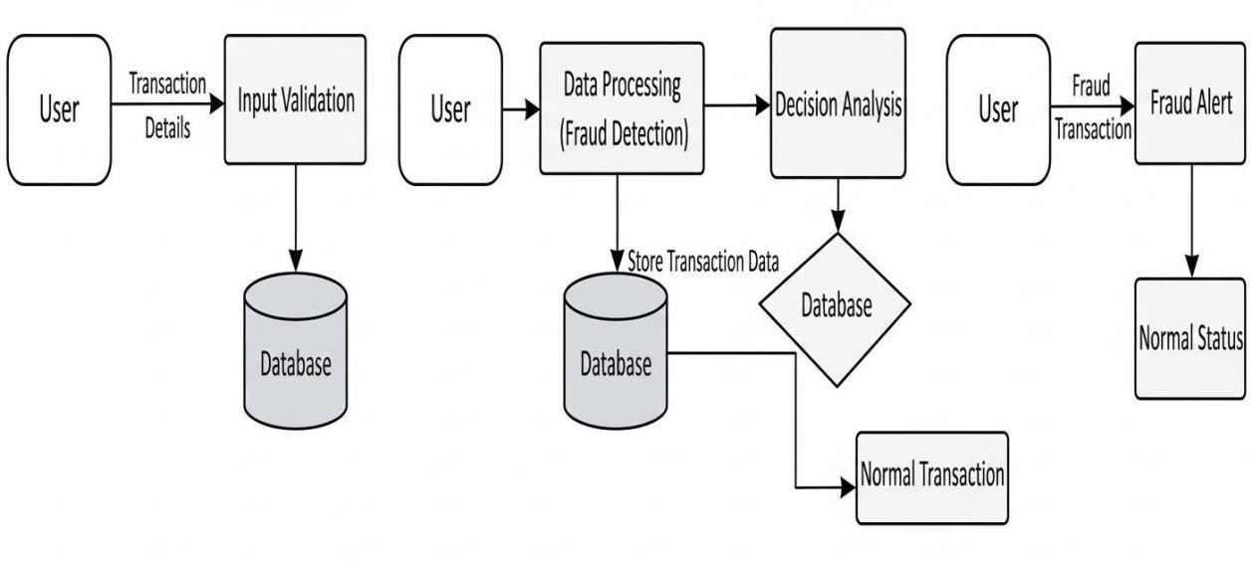

DFD – LEVEL: 1 (Context Diagram)

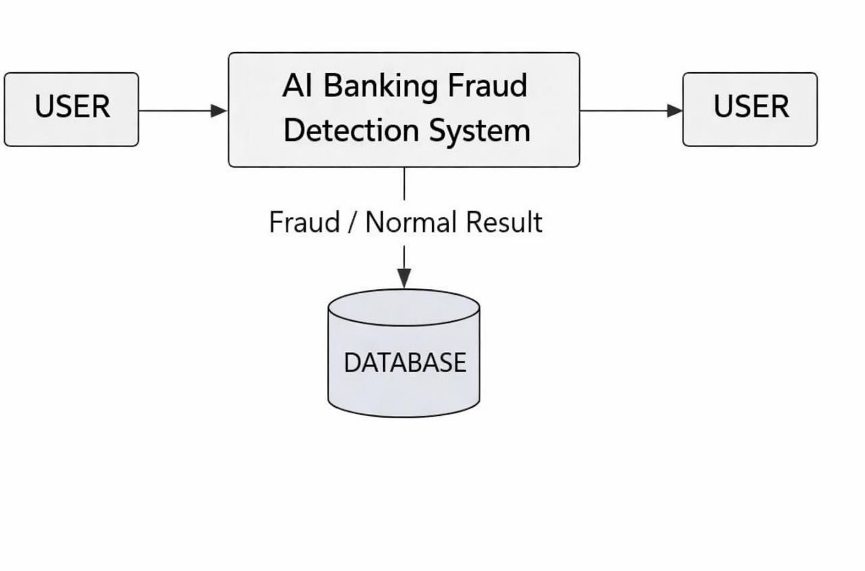

DFD – LEVEL: 2 (Detailed Fraud DetectionDiagram)
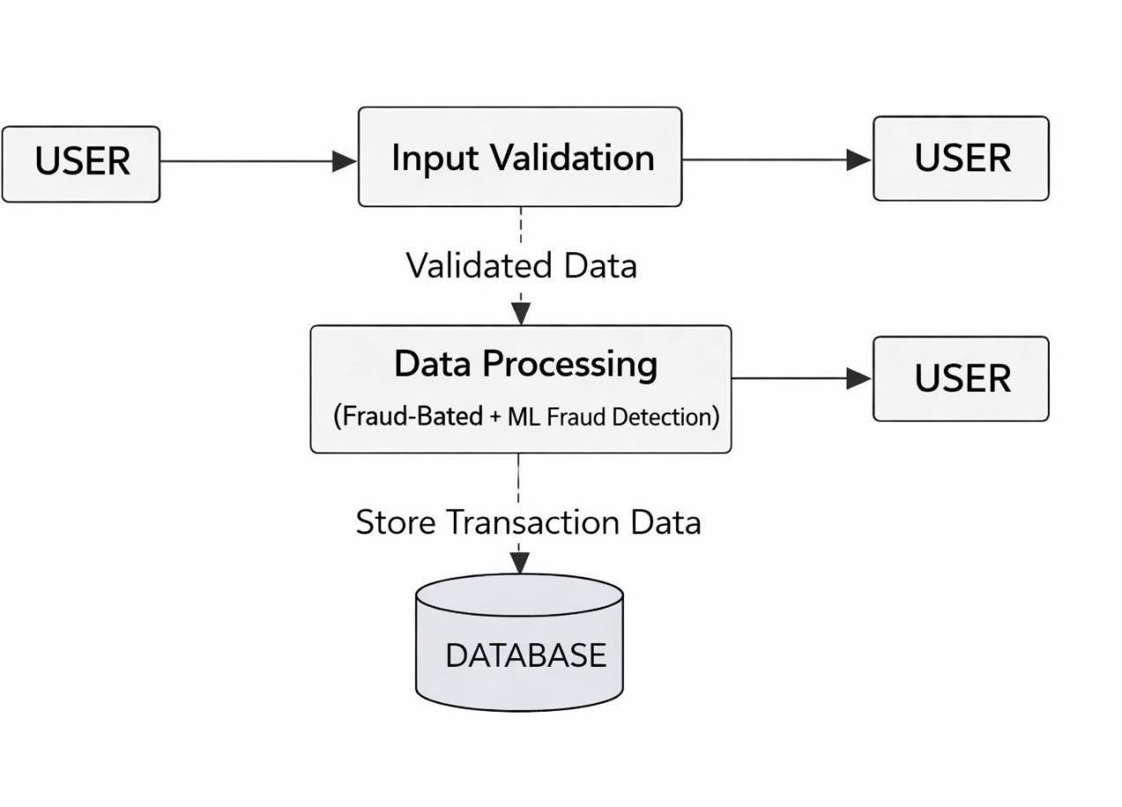

Table Structure

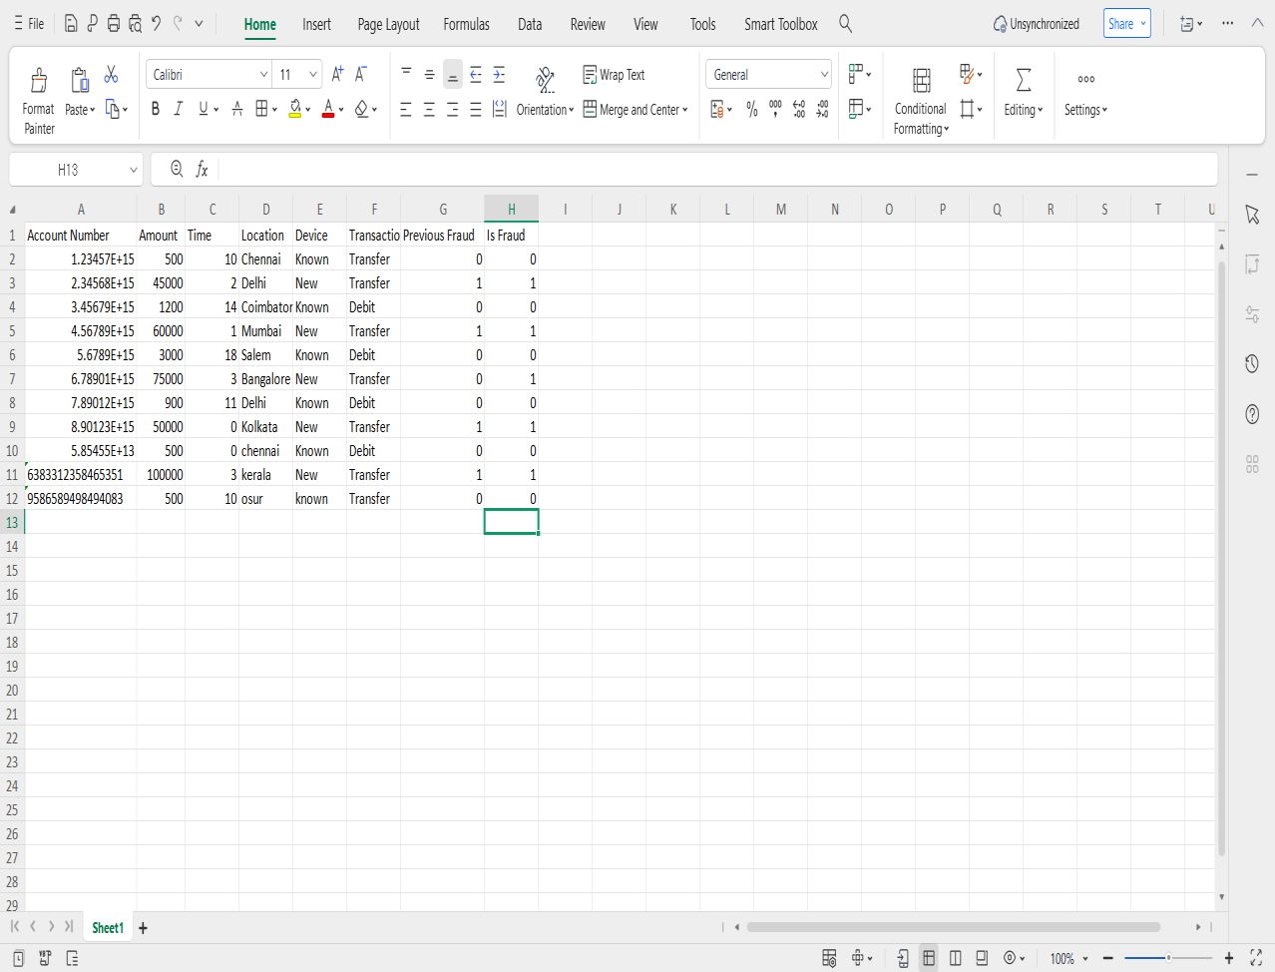

Table 1: User TransactionDetails Table
Description: This table storesthe transaction details entered bythe user.

file name | data type | descerption
Account_Number | Text | User’s bank account number
Transaction_Amount | Numeric | Amount ofthe transaction
Transaction_Time | Numeric | Time oftransaction (0–23 hours)
Location | Text | Transaction location
Device_Type | Text | Device used (Known / New)
Transaction_Type | Text | Type oftransaction (Debit / Transfer)
Previous_Fraud_Count | Numeric | Number ofprevious fraud records

Table 2: Fraud Detection Result Table
Description: This table storesthe fraud detection outcome for each transaction.

Field Name | Data Type | Description
Account_Number | Text | User’s bank account number
Fraud_Status | Numeric | 0 – NormalTransaction, 1 – Fraud Transaction
Detection_Method | Text | Rule-Based / Machine Learning / Hybrid
Detection_Time | Date & Time | Time when fraud detection was performed

Sample coding:

Front End: Index.html

<!DOCTYPE html>
<html>

<head>

<title>AI Banking Fraud Detection</title>

<link href="https://cdn.jsdelivr.net/npm/bootstrap@5.3.2/dist/css/bootstrap.min.css" rel="stylesheet">
</head>
<bodyclass="container mt-5">

<h1 class="text-center">AI-Based Banking Fraud Detection</h1>

<form method="POST" class="mt-4">

<!-- Account Number -->

<input type="text" name="account" placeholder="Account Number" class="form-control mb-2" required>
<!-- Amount (TYPE panna allow aagum) -->
<input type="text" name="amount" placeholder="Amount" class="form-control mb-2" inputmode="numeric"
required>
<!-- Time (TYPE panna allow aagum) -->
<input type="text" name="time"

placeholder="Time (0-23)" class="form-controlmb-2" inputmode="numeric" required>
<!-- Location -->
<input type="text" name="location" placeholder="Location" class="form-control mb-2" required>
<!-- Device (DROPDOWN) -->
<select name="device" class="form-control mb-2" required>
<option value="">Select Device</option>

<option value="Known">Known</option>

<option value="New">New</option>

</select>

<!-- Transaction Type (DROPDOWN) -->

<select name="txn_type" class="form-control mb-2" required>

<option value="">Select Transaction Type</option>

<option value="Debit">Debit</option>

<option value="Transfer">Transfer</option>

</select>

<!-- Previous Fraud Count -->

<input type="number" name="prev_fraud" placeholder="Previous Fraud Count" class="form-control mb-2"

required>

<buttontype="submit" class="btn btn-primaryw-100"> Check Transaction
</button>
</form>

{% ifresult %}

<h2 class="mt-4">Result: {{ result }}</h2>

{% endif %}

{% if show_charts %}

<h3 class="mt-3">Visualizations</h3>

<img src="{{ url_for('static', filename='bar_chart.png') }}" width="400"><br><br>

<img src="{{ url_for('static', filename='line_chart.png') }}" width="400"><br><br>

<img src="{{ url_for('static', filename='pie_chart.png') }}" width="400">

{% endif %}

</body>

</html>

BackEnd: app.py

from flask import Flask, render_template, request from main import detect_fraud, generate_charts app = Flask( name )
@app.route("/", methods=["GET","POST"]) def index():
result_text = None show_charts= False ifrequest.method == "POST":
# --- Get form input ---
account = request.form["account"] amount =float(request.form["amount"]) time = int(request.form["time"]) location = request.form["location"] device = request.form["device"] txn_type = request.form["txn_type"]
prev_fraud = int(request.form["prev_fraud"])

# --- Detect fraud (account number included) --- result = detect_fraud(
account, # <-- account number passed here amount,
time, location, device, txn_type,

prev_fraud
)

# --- Generate charts --- generate_charts(result) # --- Result text ---
result_text = "Fraud Transaction ❌" ifresult == 1 else "NormalTransaction ✅" show_charts = True
returnrender_template("index.html", result=result_text, show_charts=show_charts) if name == " main ":
app.run(debug=True)

Main.Py

import pandas as pd

import matplotlib.pyplot asplt import os
fromsklearn.ensemble import RandomForestClassifier from sklearn.preprocessing import LabelEncoder
# Pathto dataset
DATASET_FILE = "fraud_dataset_upload.xlsx" # Load dataset if exists
columns = ['Account Number','Amount','Time','Location','Device','Transaction Type','Previous Fraud','Is Fraud']
ifos.path.exists(DATASET_FILE):

df = pd.read_excel(DATASET_FILE) else:
df = pd.DataFrame(columns=columns) # Train ML model if dataset has data if not df.empty:
le_location = LabelEncoder() le_device = LabelEncoder() le_txn_type = LabelEncoder()
df['Location_code'] = le_location.fit_transform(df['Location']) df['Device_code'] = le_device.fit_transform(df['Device']) df['TxnType_code'] =le_txn_type.fit_transform(df['Transaction Type'])
X = df[['Amount','Time','Location_code','Device_code','TxnType_code','Previous Fraud']]
y= df['Is Fraud']

model= RandomForestClassifier() model.fit(X, y)
else:
le_location = le_device = le_txn_type = None model = None
# ----------------- Save user input automatically -----------------

defsave_user_input(account, amount, time, location, device, txn_type, prev_fraud, result):
# Load existing dataset ifos.path.exists(DATASET_FILE):
df_existing = pd.read_excel(DATASET_FILE) else:
df_existing = pd.DataFrame(columns=columns) # Create new row as DataFrame
new_row = pd.DataFrame([{

'Account Number': account, # <-- exact match 'Amount': amount,
'Time': time, 'Location': location, 'Device': device,
'Transaction Type': txn_type, 'Previous Fraud': prev_fraud, 'Is Fraud': result
}])
# Concatenate

df_existing = pd.concat([df_existing, new_row], ignore_index=True)

# Save back to Excel df_existing.to_excel(DATASET_FILE, index=False) # Detect Fraud
defdetect_fraud(account, amount, time, location, device, txn_type, prev_fraud): # Rule-based detection
rules_fraud = 0
ifamount > 10000 and (time < 6 ortime > 22) and location.lower() != "chennai": rules_fraud = 1
# ML prediction ml_pred = 0
ifmodel is not None:
loc_code = le_location.transform([location])[0] if location in le_location.classes_ else 0
device_code = le_device.transform([device])[0] ifdevice in le_device.classes_ else 0

txn_code= le_txn_type.transform([txn_type])[0] iftxn_type in le_txn_type.classes_ else 0

ml_pred = model.predict([[amount, time, loc_code, device_code, txn_code, prev_fraud]])[0]
final_result = 1 ifrules_fraud == 1 or ml_pred == 1 else 0 # Save user input including account number
save_user_input(account, amount, time, location, device, txn_type, prev_fraud, final_result)
return final_result

# Generate Charts

def generate_charts(result): os.makedirs("static", exist_ok=True) labels = ['Normal','Fraud']

values = [0,0]

values[result] = 1 colors=['green','red'] # Bar chart plt.figure()
plt.bar(labels, values, color=colors) plt.title("Transaction Result (Bar Chart)") plt.savefig("static/bar_chart.png") plt.close()
#Linechart plt.figure()
plt.plot(['Transaction'], [result], marker='o') plt.yticks([0,1], ['Normal','Fraud']) plt.title("Transaction Status (Line Chart)") plt.savefig("static/line_chart.png") plt.close()
#Piechart plt.figure()
plt.pie([1-result, result], labels=['Normal','Fraud'], colors=['green','red'], autopct='%1.1f%%')
plt.title("Fraud Percentage") plt.savefig("static/pie_chart.png") plt.close()

Sample Input:

Sample Input 1 (Normal Transaction):

Account Number 123456789012
Transaction Amount 750
Transaction Time 23
Location : Chennai Device Type : Known Transaction Type :Transfer Previous Fraud Count : 0

Sample Input 2 (Fraud Transaction):

Account Number | 987654321098
Transaction Amount | 50000
Transaction Time | 0
Location : | Mumbai
Device Type | : Knew
Transaction Type | : Debit
Previous Fraud Count : 1

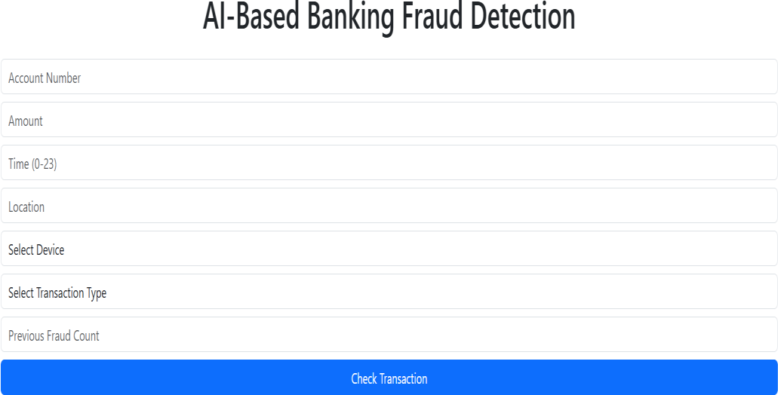

Sample Output :

Normal Transaction:

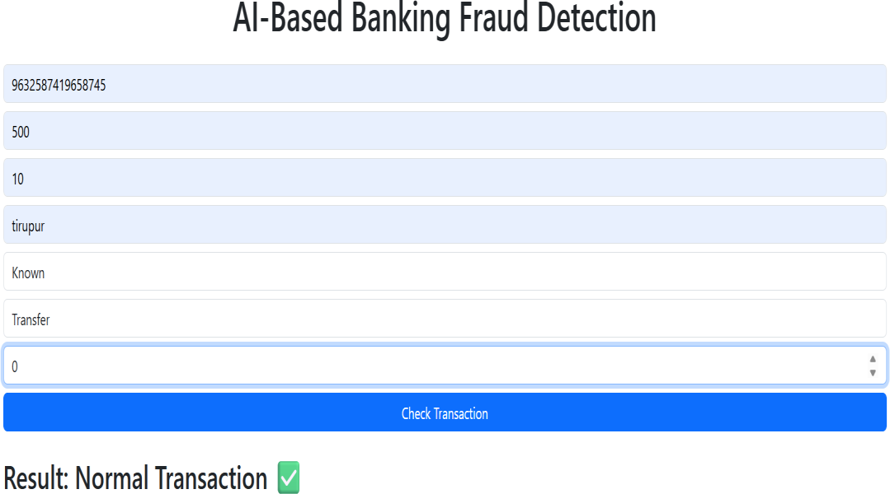

Fraud Transaction:

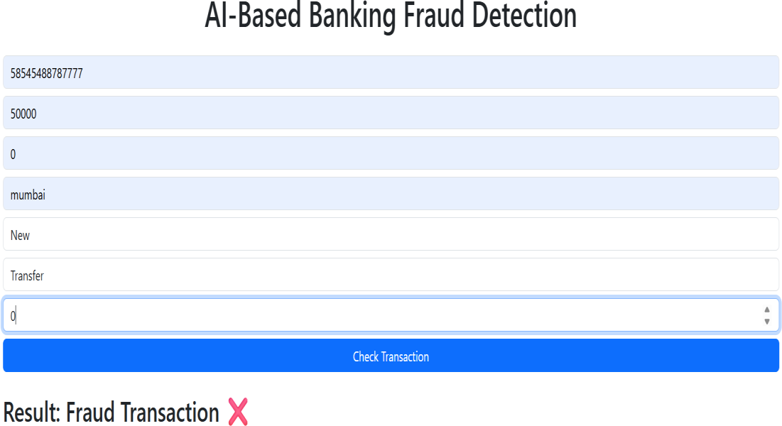

Visualization: Bar Chart:
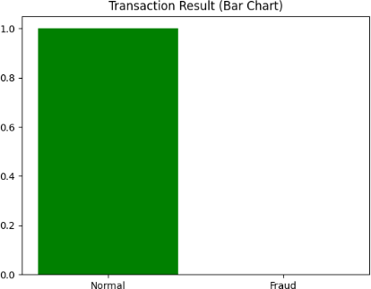

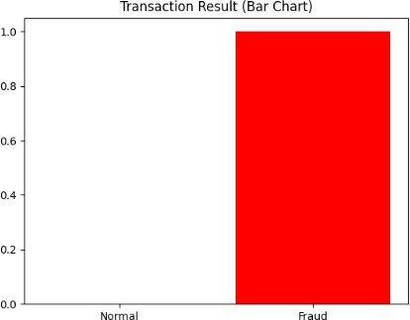

Description
The bar chart is an important visualization tool used in this project to represent the transaction result in a clear and understandable way. It helps users visually compare normal and fraudulent transactions. Instead of only displaying the result as text, the bar chart provides a graphical representation, which makes the output easier to interpret.
In this fraud detection system, the bar chart contains two main categories: Normal Transactions and Fraud Transactions. These two categories are represented using vertical bars. The height of each bar indicates the transaction status. If the transaction is normal, the "Normal" bar will have value 1 and the "Fraud" bar will have value 0. If the transaction is fraudulent, the "Fraud" bar will have value 1 and the "Normal" bar will have value 0.

The bar chart helps users quickly understand the transaction outcome without reading long explanations. Visual representation improves clarity and makes the system more user-friendly. It also helps in better decision-making by clearly showing whether the transaction is safe or risky.
The bar chart is generated dynamically after each transaction is processed. It is created using the Matplotlib library in Python and saved inside the static folder. The generated chart image is then displayed on the web interface along with the fraud detection result.
Using a bar chart improves the overall presentation of the system and enhances user experience. It makes the fraud detection result more interactive and visually appealing. Therefore, the bar chart plays an important role in the visualization module of this project.

Line Chart:

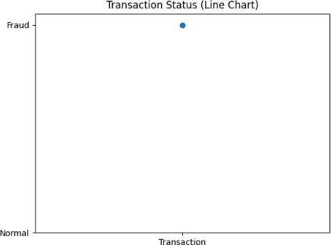
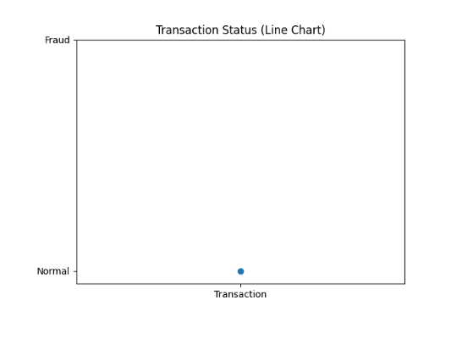
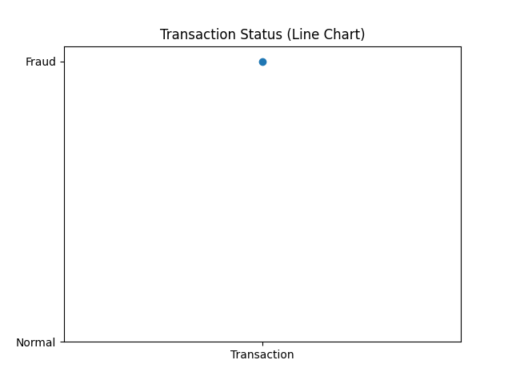

Description

The line chart is used in this project to represent the transaction status in a simple and clear graphical format. It helps users understand whether the transaction is normal or fraudulent in a visual way. Instead of showing only text output, the line chart provides a graphical representation, which improves clarity and user understanding.

In this fraud detection system, the line chart shows the transaction result on a simple axis. The horizontal axis represents the transaction, and the vertical axis represents the transaction status. The value 0 indicates a Normal transaction, and the value 1 indicates a Fraud transaction. A point is plotted on the graph based on the prediction result, and it is connected using a line to clearly show the transaction status.

The main purpose of using a line chart is to visually indicate the outcome of the fraud detection process. It helps users quickly identify whether the transaction is safe or risky. The line chart makes the output more interactive and easy to interpret.
The chart is generated dynamically after each transaction is processed. It is created using the Matplotlib library in Python and saved in the static folder. The generated image is thendisplayed onthe webpage along with the fraud detection result.
Even though only one transaction is shown at a time in this project, the line chart demonstrates how transaction trends can be visualized. In future enhancements, this chart can be extended to display multiple transactions and show trends over time.

Therefore, the line chart plays an important role in the visualization module by improving the presentation and making the fraud detection result more understandable.

Pie Chart:

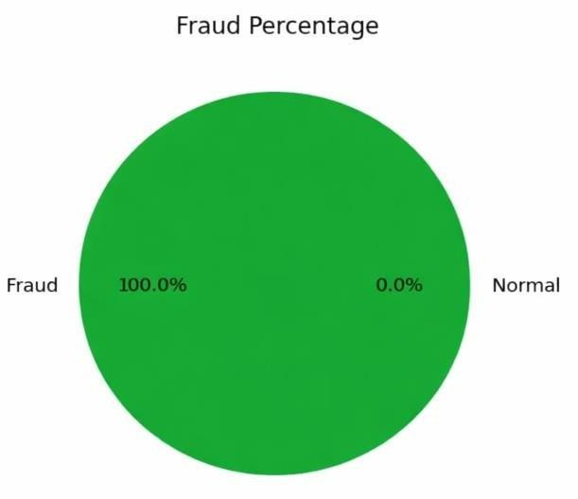

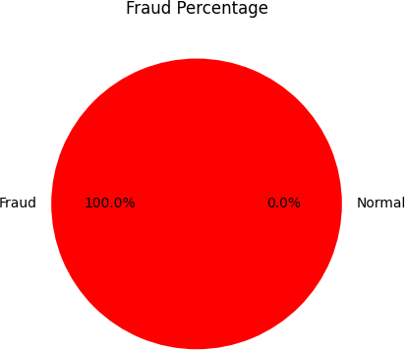

Description
The pie chart is used in this project to visually represent the percentage of normal and fraudulent transactions in a clear and attractive format. It helps users easily understand the transaction result by displaying it in a circular graphical form. Compared to plain text output, the pie chart makes the result more interactive and visually understandable.

In this fraud detection system, the pie chart consists of two main sections: Normal Transactions and Fraud Transactions. The circle is divided into slices based on the prediction result. If the transaction is normal, the larger portion of the pie chart represents the normal category. If the transaction is fraudulent, the larger portion represents the fraud category.
Each section of the pie chart shows the percentage value, which makes it easy for users to quickly identify the transaction status. The use of different colors helps in clearly distinguishing between normal and fraud transactions. This improves the readability and presentation of the system output.

The pie chart is generated dynamically after the transaction is analyzed by the fraud detection system. It is created using the Matplotlib library in Python and saved inside the static folder. The generated image is then displayed on the web interface along with the fraud detection result.
The main purpose of using a pie chart in this project is to improve data visualization and make the output more user-friendly. It enhances the overall appearance of the system and helps users understand the fraud detection result more effectively.
In future improvements, the pie chart can be extended to display the overall percentage of fraud transactions from multiple records instead of a single transaction. This can help in better analysis and monitoring of fraud trends over time.
Therefore, the pie chart plays an important role in the visualization module of this project by clearly representing the fraud detection outcome in a graphical format.

